**Install Power BI Desktop and share the final screenshot of the report view page which appears when power desktop starts.**

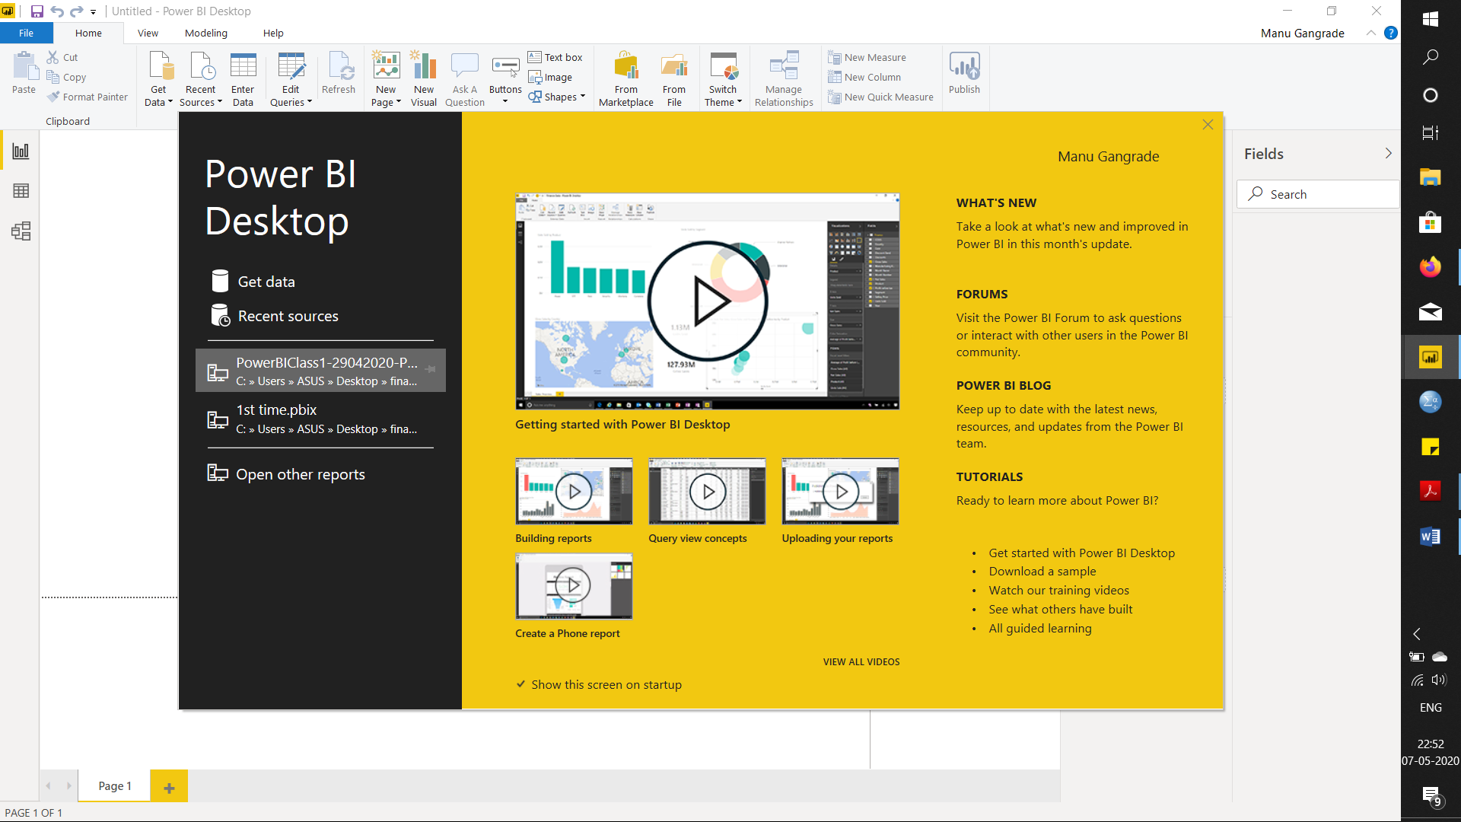

**Report View**

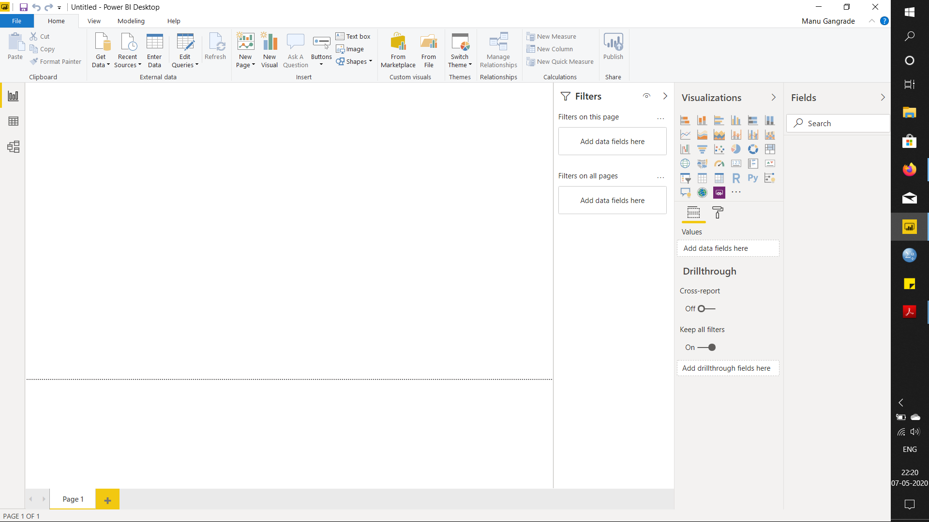

**Data View**

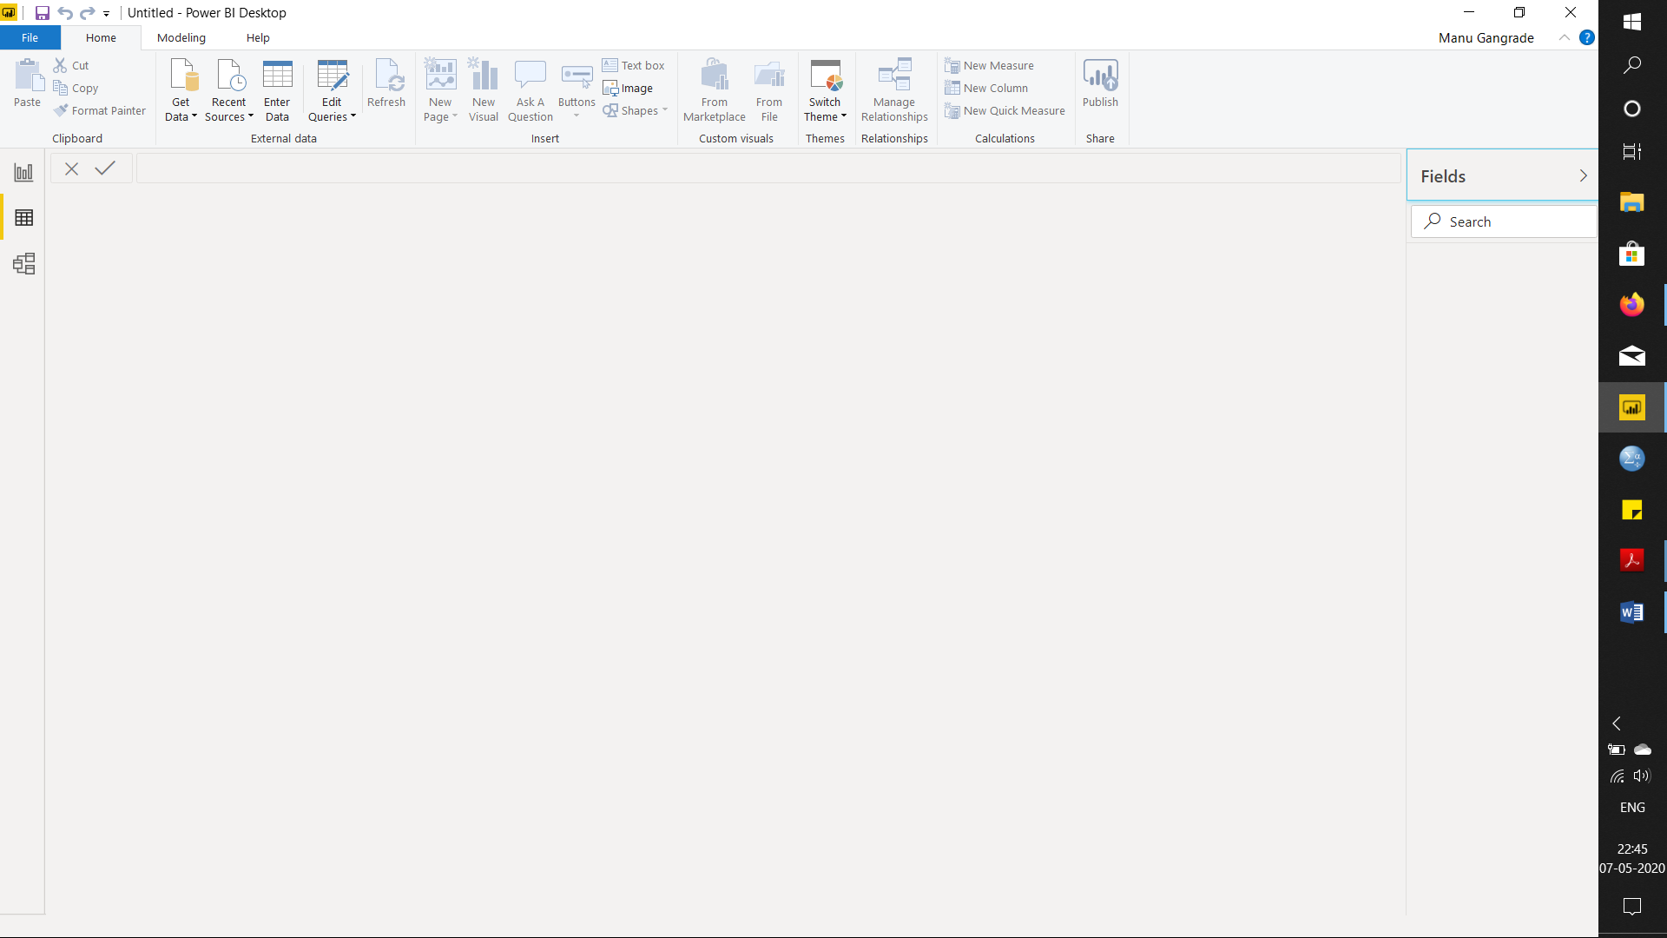

**Model View**

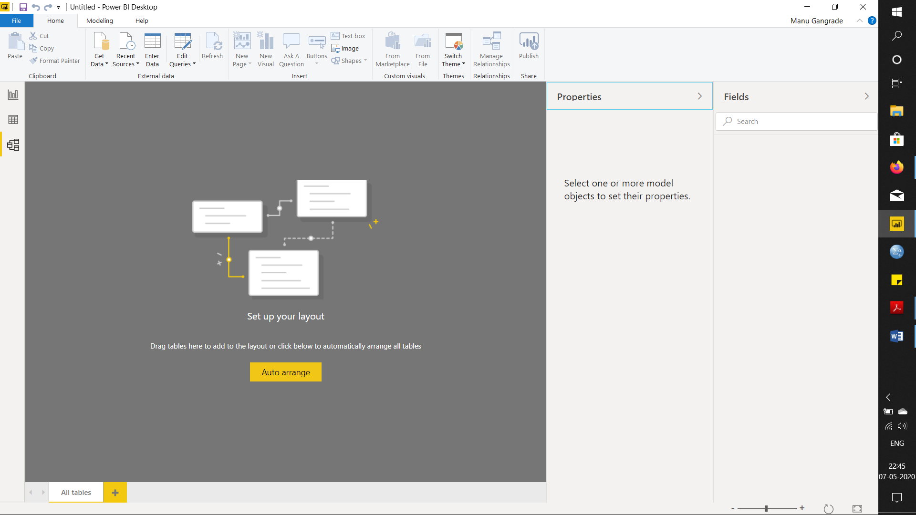

**Power Query Editor**

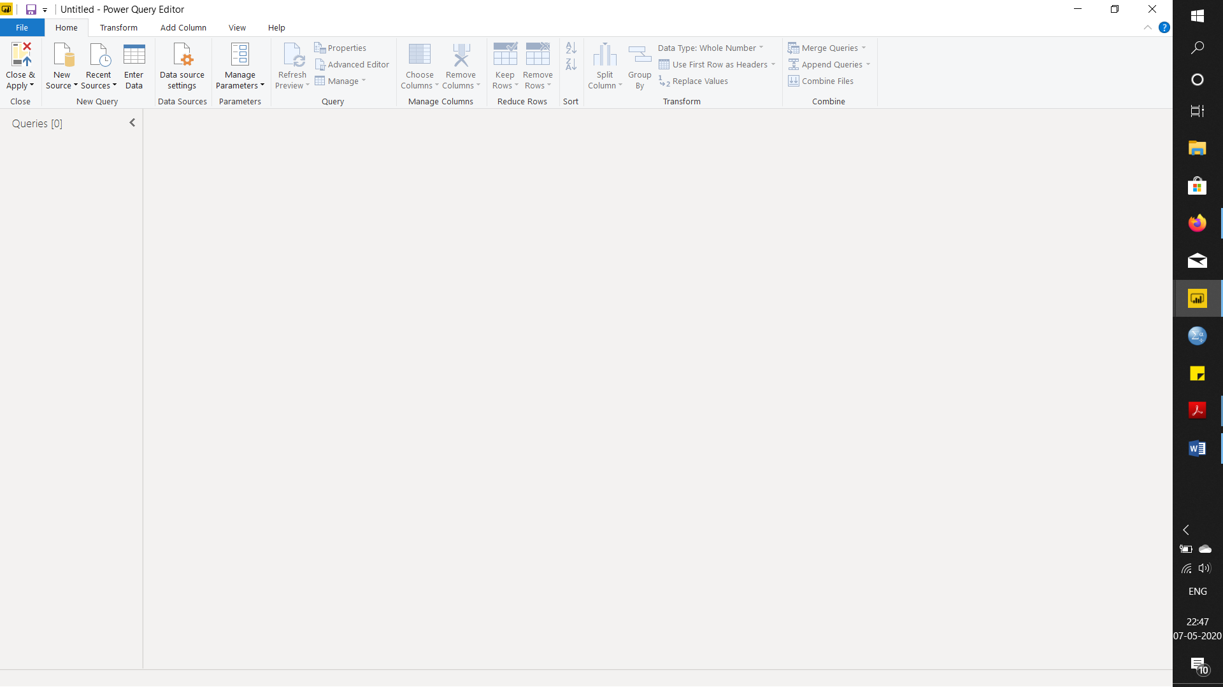

**Advance Editor**

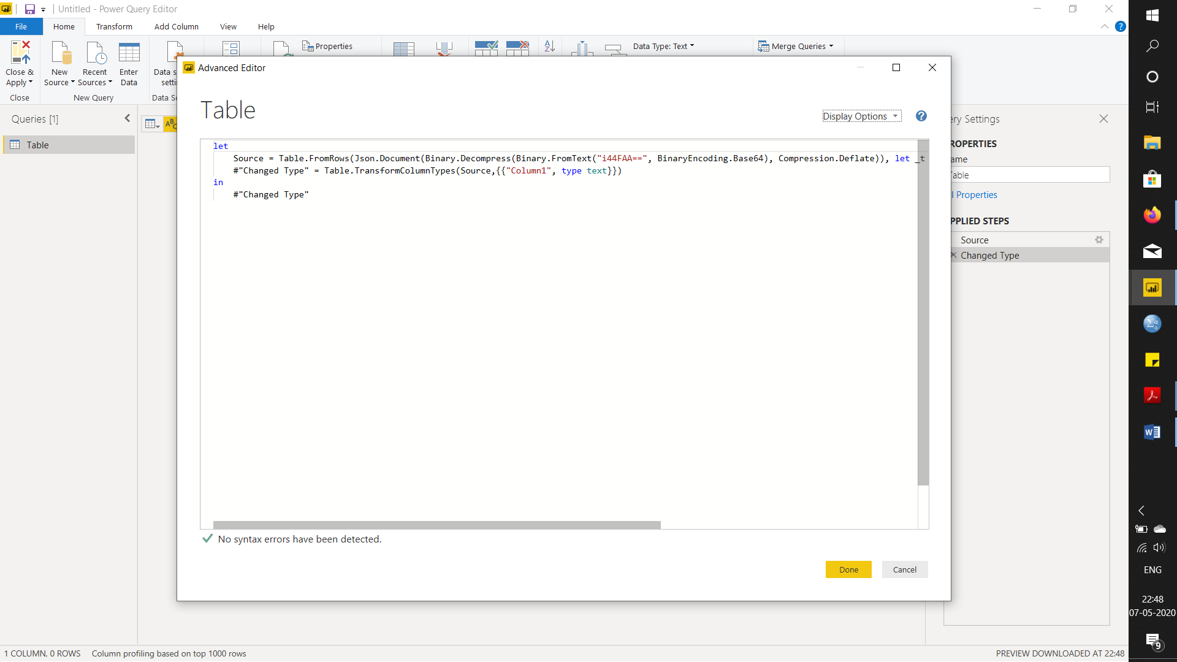

**POWER BI DESKTOP**

Power BI Desktop is a free application you install on your local computer that lets you connect to, transform, and visualize your data. With Power BI Desktop, you can connect to multiple different sources of data, and combine them (often called modelling) into a data model. This data model lets you build visuals, and collections of visuals you can share as reports, with other people inside your organization. Most users who work on business intelligence projects use Power BI Desktop to create reports, and then use the Power BI service to share their reports with others.

The most common uses for Power BI Desktop are as follows:

* Connect to data
* Transform and clean that data, to create a data model
* Create visuals, such as charts or graphs, that provide visual representations of the data
* Create reports that are collections of visuals, on one or more report pages
* Share reports with others by using the Power BI service

**Price – Free**

**POWER BI PRO**

Power BI Pro is an individual user license that allows access to all content and capabilities in the Power BI service. You can even share content and collaborate with other Pro users. Only Pro users can publish content to workspaces, share dashboards, and subscribe to dashboards and reports. This type of license is typically assigned to Power BI report designers, developers, and administrators.

**Price – $ 9.99 or Rs. 660 per user per month**

**POWER BI PREMIUIM**

Power BI Premium provides dedicated capacity to deliver more consistent performance. It also supports larger data volumes in Power BI. For individual users, Premium enables widespread distribution of content by Pro users and it doesn't require per-user Pro licenses for recipients viewing the content. This means that consumers can collaborate with colleagues and view and interact with dashboards, reports, and apps that have been shared with them.

**Price - $4995 or Rs. 330190 per month per computing cloud and storage resource.**